This specification gives the general information and requirements that the supplier shall indicate in the foundation load drawings of its equipment.
- On the drawings, the axis orientation must be indicated and “x” direction will be coincident with the horizontal axis of the machine.
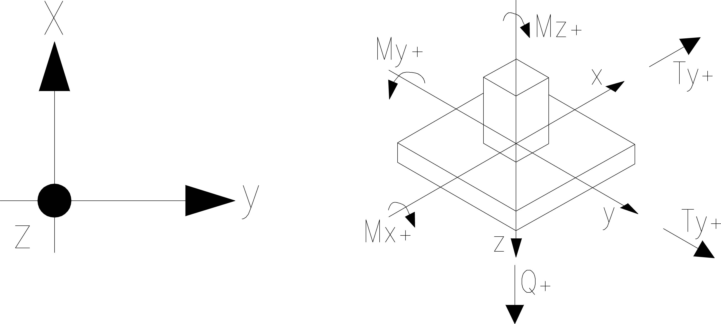
- Indicate the type of supports and anchor bolts.
SUPPORT MATERIAL: |  | ……………………………… | SUPPORT NUMBER: |  | ………………………………
TYPE OF SUPPORT: |  | ON GROUNDING | TYPE OF SCREW (see sample, note 1)
TYPE OF SUPPORT: |  | FIXED SUPPORT
TYPE OF SUPPORT: |  | SLIDING SUPPORT |  | Friction design coefficient:
TYPE OF SUPPORT: |  | OTHER (e.g. rails, beams, etc.)
N° BOLTS FOR SUPPORT: ……………………………….. |  |  | Ø BOLTS: ……..………………………………….…………………

NOTE 1
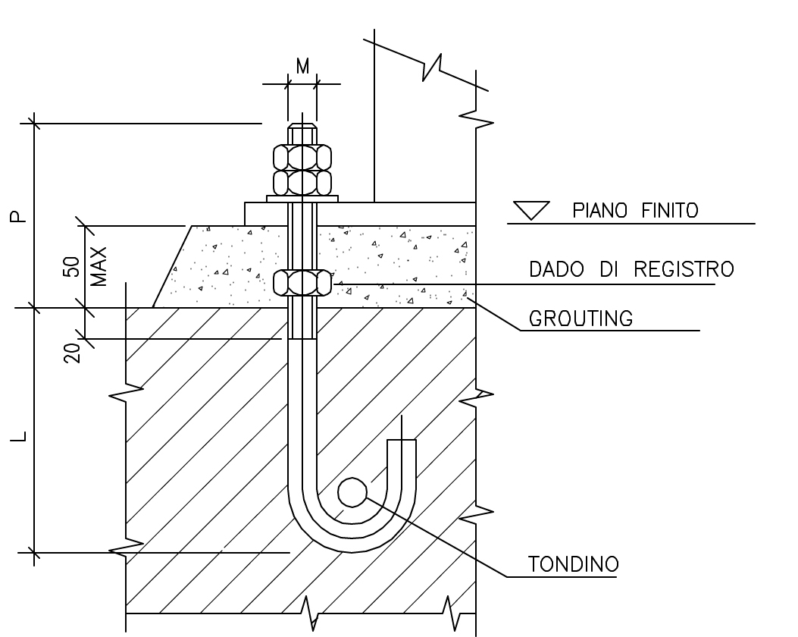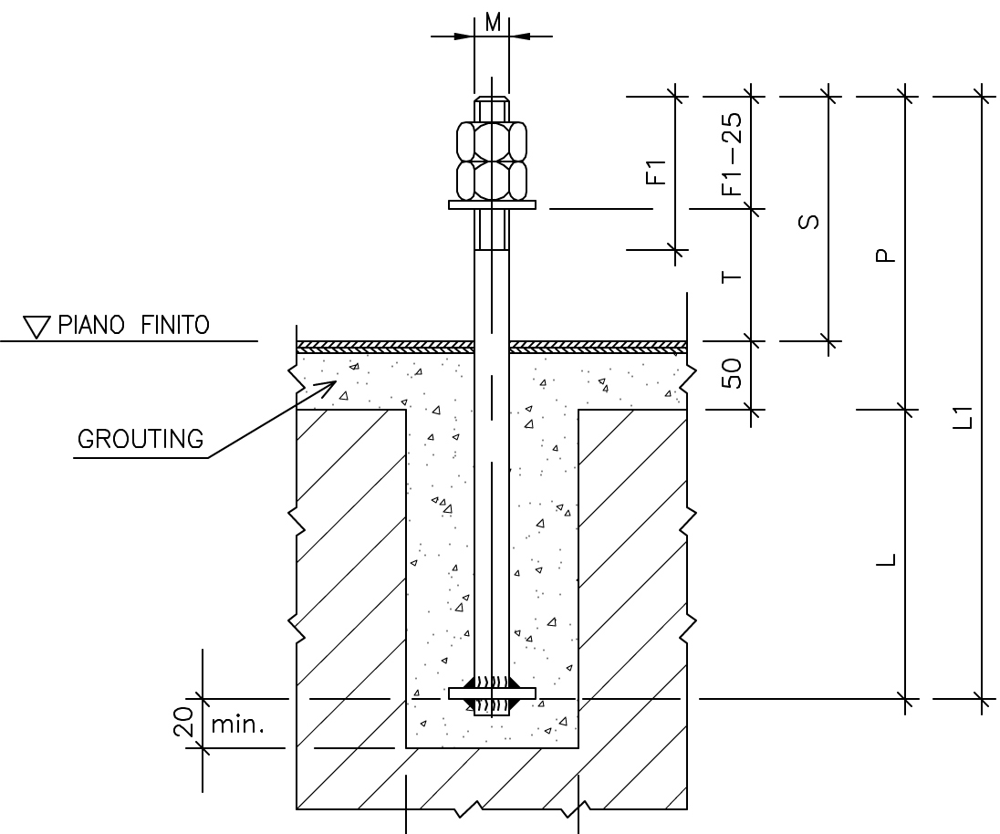

- The load indication must be different according to the type of equipment.

Light equipments (pumps, fans, chemical package, etc)
 |  | Q kN | Tx kN | Ty kN
EMPTY |  | ---- | ---- | ----

Heavy equipments (blowers, compressor, turbo generator, vessel, etc).
Wind, seismic and static forces shall be calculated and the maximum values shall be indicated in the following table:
 |  | Q kN | Tx kN | Ty kN | Mx kN | My kN | Mz kN
EMPTY |  | ---- | ---- | ---- | ---- | ---- | ----
FULL-LOAD |  | ---- | ---- | ---- | ---- | ---- | ----
OPERATING |  | ---- | ---- | ---- | ---- | ---- | ----

Ricavata da 2E94.16.002

